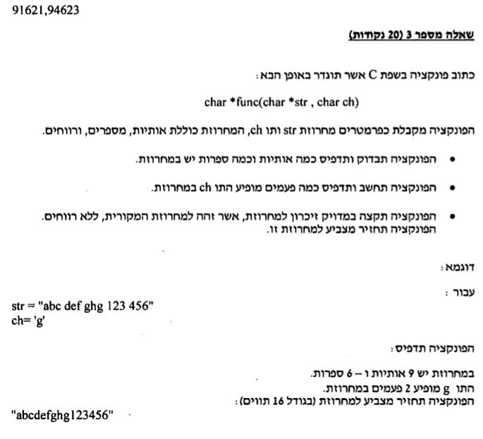

char \*func(char \*str, char ch)

{

int lettercount = 0, numbercount = 0, charnum = 0,spacecount=0;

int i,j=0;

char \*newstr = NULL;

for (i = 0; i < strlen(str); i++)

{

if (isalpha(str[i]))

{

lettercount++;

if (str[i] == ch)

charnum++;

}

else if (isdigit(str[i]))

numbercount++;

else if (isspace(str[i]))

spacecount++;

}

printf("there are %d letters in the string\n", lettercount);

printf("there aree %d numbers in the string\n", numbercount);

printf("the letter %c appears in the string %d time\n", ch, charnum);

newstr = (char\*)malloc(sizeof(char)\*(strlen(str)-spacecount));

for (i = 0; i < strlen(str); i++)

{

if (!isspace(str[i]))

{

newstr[j] = str[i];

j++;

}

}

newstr[j] = '\0';

return newstr;

}

void main()

{

char str[255];

char ch;

printf("please enter a string: ");

gets(str);

printf("please enter a char: ");

scanf("%c", &ch);

puts(func(str, ch));

}